**Objectives**

In this hands-on lab, you will learn how to implement git ignore command to ignore unwanted files and folders

**Step 1 - Create .log file and folder in GitDemo**

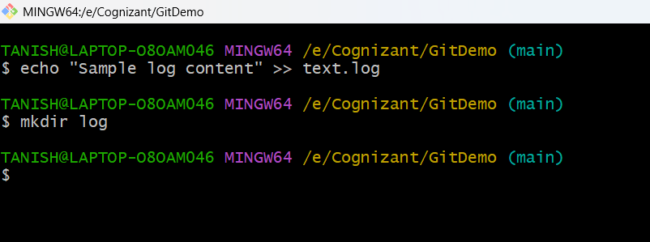

**Step 2 - Create .gitignore file**

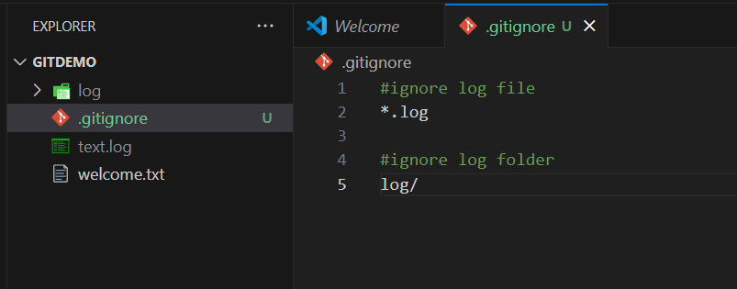

**Step 3 - Verify with git status then stage and commit**

